Lake Manawa In-Lake Buoy Plan

Project No. 14-0478-03
Pottawattamie County, IA

Prepared for
Iowa Department of Natural Resources
Engineering Bureau

Prepared by
JF Brennan Co., Inc.

Buoy and Safety Marker Delineation Plan
Communication of work zones to the boating public of Lake Manawa is vitally important to the safe and successful completion of the work. As such, the following steps will be taken to prevent the boating public from entering areas where operations are ongoing.
The dredge pipeline markings used on the Lake Manawa Project will consist of a series of different waterway markers, the first of which are orange pipeline delineators measuring 18-in. in diameter. Each pipeline delineator will be placed at a maximum of 150ft along the dredge pipeline and secured directly to the pipeline.
In addition to the pipeline delineators, white stick buoys with black and orange reflective markings stating “Danger Pipeline” and/or “No Wake Zone” will be placed on each side of the pipeline. The white stick markers will be spaced at a maximum of 500ft longitudinally on center from one another and alternate on each side of the pipeline along the entire line length until reaching the dredge area. This will clearly mark the pipeline route and by staging the buoys on each side will give the appearance that the stick buoys are 250ft apart.
A temporary dredging zone will be created with a maximum area of 5 acres. This area will be encircled with stick markers spaced at 250ft intervals to clearly define the work location. Each stick marker delineating the area will have a yellow light visible for up to two miles as per U.S. Coast Guard (USCG) Regulation 33CFR88.15 These stick markers will be connected to the pipeline corridor markers which will delineate the entire work zone..
Finally, large floating signage will be placed around the temporary dredge zone to notify any vessels entering this area of the potential hazards. These signs will read “Danger Pipeline” and “Danger Construction Zone Stay in Channel” and “No Wake Zone” and will have reflective tape and mooring lights to better identify the markers during periods of low visibility.
To facilitate the safe passage of pleasure boaters around the work zone a channel will be located on the north side of the dredge area as shown on the project plans. Navigational buoys will be installed creating a channel of safe passage. The passage way will be marked with both red and green stick markers located on each side of the channel to identify the area of safe passage. Both sets of markers will have associated red and green lights attached to the top for better visibility.
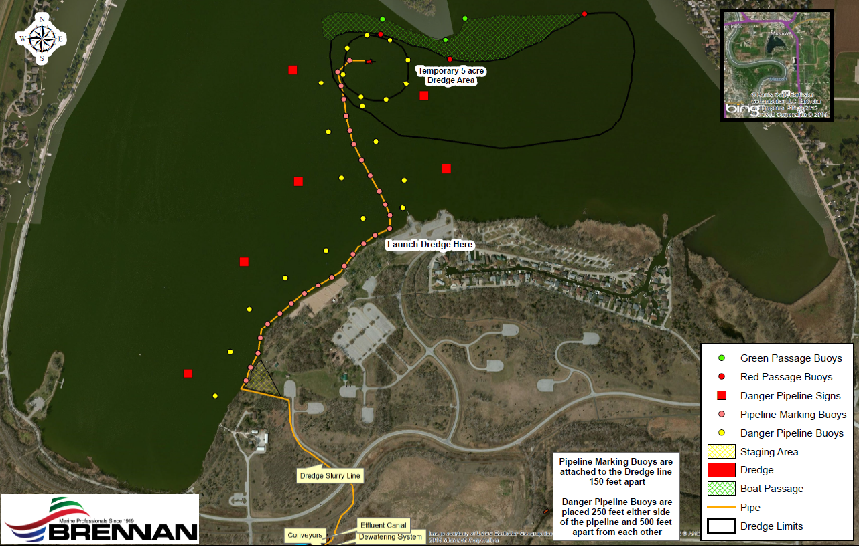
Figure A Example of In-Lake Buoy Layout

The marking plan for the dredge pipeline has been modeled after the methods used by the U.S. Army Corps of Engineers (USACE). Furthermore, Brennan has used this method, with great success, on several USACE projects where various agencies including the DNR, EPA, and the USCG have had environmental and regulatory oversight.

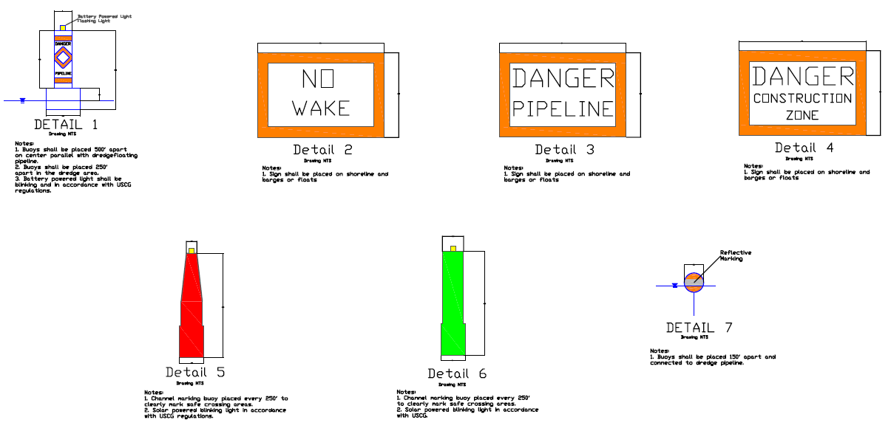
Figure A Example of In-Lake Buoy Layout

The dredge pipeline used for sediment removal on the Lake Manawa Project is an HDPE line that undulates between a submerged and semi-submerged position depending on the sediment load in the dredge pipeline. However with the targeted material being sand for this project the pipeline will be predominately submerged on the bottom of the lake due to the weight of the material. Periodically the pipeline will be weighted or anchored to the bottom of the lake to prevent unwanted movements.
In addition to pipeline safety JF Brennan will utilize the dredge Victor Buhr which is a swinging ladder dredge requiring no swing cables. This results in a much safer operation for site workers and recreational boaters than a traditional dredge. Traditional dredges utilize long swing cables attached to anchors. These cables and anchors are stretched across the lake to move the dredge into location while digging. All of JF Brennan’s dredges are swinging ladder dredges designed to eliminate this safety concern. Swinging ladder dredges are powered with hydraulic cylinders to move the dredge ladder while digging. In addition to the swinging ladder all of Brennan’s dredges utilize power bow and stern spuds. The stern spuds are walking spuds. By employing powered walking spuds Brennan dredges will move themselves across the lake safely provided a safe environment for both the workers and public.
All of the working and support equipment will be marked with lighted buoys and signage per the USCG as needed to ensure easy public visibility.

Park Safety
In addition to the buoys placed out in the lake, signs will be posted at each of the boat ramps in order for boaters to view. The signs will include pictures of the various types of buoys utilized on the water and will have a brief explanation of what each buoy means. Signs will measure approximately 12” by 20” for clear viewing of the information.

Brennan will utilize a high speed dewatering system in the stockpile area. This will eliminate large areas of ponded water and unstable sediments. The dry sand from the dewatering plant will be stockpiled in the designated areas and all of the water will be returned to the lake via a 16” pipeline.

Light plants and temporary powered lighting will be utilized in all necessary areas for worker safety. The dewatering plant will be powered by portable generators providing any of the needed electrical requirements.

All entrances to the stockpile area will be chained with appropriate signage to restrain the public from entering the job site. All storage containers and control shacks will be locked when not occupied to prevent the public from entry.

In closure JF Brennan will continue to utilize its 96 years of marine experience working in and around the public to ensure that the dredging and dewatering of sediments at Lake Manawa are performed safely and efficiently. Throughout the project divisional management and corporate safety will also visit the project ensuring that compliance for the project specifications and regulatory authorities is being upheld with the upmost of professionalism.

