L A K E M A N A W A F I R E W O R K S 2 0 1 6

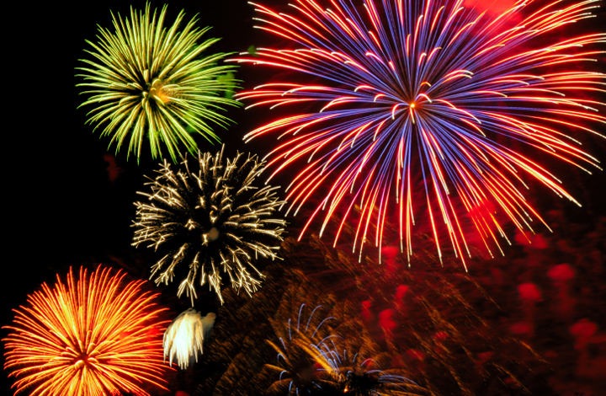

Please join us as a Sponsor for the 2016 Lake Manawa Fireworks display and help give our Council Bluffs community a special event. This year’s event will be Saturday, July 2, 2016. At each sponsorship level, you will receive corresponding recognition. Questions? Call Jeremy or Jerry at 712-366-0525. Would you please consider a contribution at one of these levels:
- $5,000 Presenting Sponsor (Thank You in Print/Radio, 8 Golf Certificates)
- $2,500 Star Sponsor (Thank You in Print/Radio, 4 Golf Certificates)
- $1,000 Patriot Sponsor (Thanks You in Print/Radio, 2 Golf Certificates)
- $500 Firecracker Sponsor (2 Golf Certificates)
- Other _________
Send Your Contribution: Friends of Lake Manawa, c/o Gary Woods, 12 Westlake Village, 51501
Or, donate online at: http://www.friendsoflakemanawa.org/ (click on donate)
2016 Fireworks Committee:
Trent Cozad Jeremy Buthe Bryan Biederman
Tom Braddy Jerry Willer Todd McCarty

