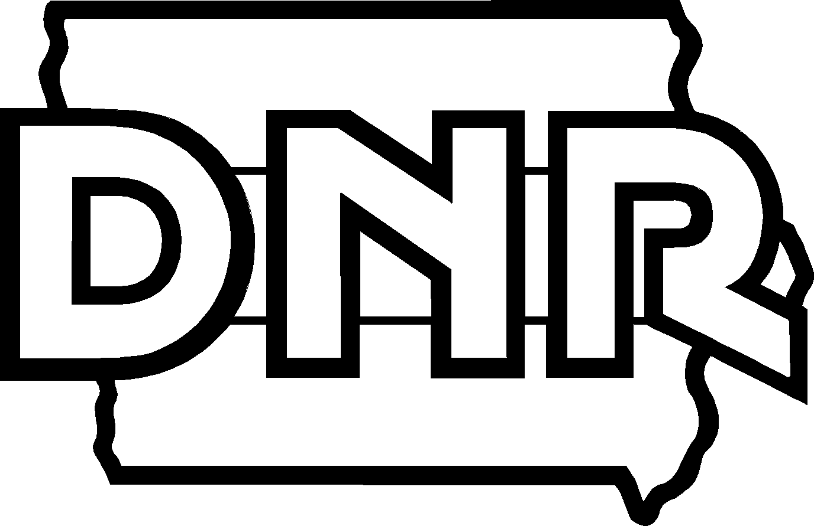 | Iowa DNR Volunteer Release and Liability Waiver
Please print in ink and complete this entire form. This document shall be retained by DNR involved in managing the activities described herein and may be referred to and shared as described herein.

Volunteer Information:
Volunteer name (first and last): |  |  |  |  |  |  |  |  |  | Primary phone:
Zip code: |  |  |  |  |  |  | Email:
In Case of Emergency Information:
Name(first and last): |  |  |  |  |  |  |  |  | Relationship to Volunteer:
Primary phone: |  |  |  |  |  |  |  |  | Secondary phone:
Volunteer Activity Description:
 | - Picking up trash/litter/debris at Lake Manawa State Park
Potential Risks and Considerations:
- Use leather gloves when picking up any sharp object (i.e. glass, metal, etc)
- Use caution when working near roadways
- Avoid natural hazards (poison ivy, bees, wasps, ticks)
DNR contact person: |  |  |  |  | Dan Jacobs |  |  |  |  |  | Phone: |  | 712-366-0220

INDIVIDUALS WILL NOT BE PERMITTED TO VOLUNTEER WITHOUT COMPLETING A RELEASE AND WAIVER FORM.
IN WITNESS WHEREOF, Volunteer has executed this Release as of the day and year first written below.
Signature: |  |  | Date:
Legal Guardian signature (if the volunteer is a minor under the age of 18)

This Release and Waiver of Liability (the “Release”) is executed by the volunteer or the legal guardian of a youth (any person under the age of 18 years of age) who is volunteering (the “Volunteer”) in favor of Iowa Department of Natural Resources (DNR), DNR’s director, employees and volunteers. The Volunteer desires to work as a Volunteer for the DNR and engage in activities related to being a volunteer (the “Activities”). The Volunteer understands that the Activities may include use of hand tools, power tools, equipment and machinery, as well as working indoors or outdoors.
The Volunteer hereby freely, voluntarily, and without duress executes this Release for the Volunteer’s self, personal representatives, heirs, and next of kin under the following terms:
Release and Waiver: Volunteer does hereby release, forever discharge, covenant not to sue, and hold harmless the DNR and its successors and assigns from any and all liability, claims, and demands of whatever kind or nature, either in law or in equity, which arise or may hereafter arise from Volunteer’s Activities on behalf of the DNR.
Medical Treatment: Volunteer does hereby release and forever discharge the DNR, its Director, and employees, from any claim whatsoever which arises or may hereafter arise on account of any first aid, treatment, or service rendered in connection with the Volunteer’s Activities with the DNR. By signing this agreement, you, the undersigned hereby agree to and authorize the following:
- DNR may seek medical treatment or service, including without limitation first aid, hospitalization and emergency ambulance service, for the Volunteer in connection with the Volunteer’s participation in the Activity. The Volunteer or their Guardian shall remain financially responsible for any costs incurred as a result of said treatment and services and hereby agree to make full payment for such to the attending medical personnel and/or health care facility rendering such treatment and services. DNR shall make every effort to contact the Volunteer and the emergency contact provided in this Agreement in the event such care is sought.
- DNR may share information contained in this Agreement as well as other documents and information related to the Volunteer otherwise in its possession with other DNR staff, Activity sponsors and volunteers, and health providers in seeking such medical treatment or service for the Volunteer.
Assumption of the Risk: The Volunteer understands that the Activities may include work that may be hazardous to the Volunteer, including, but not limited to, construction, loading and unloading, and transportation to and from the work sites. Volunteer agrees to inspect all work sites and the tools for all Activities. The Volunteer shall only perform such Activities as the Volunteer has been properly trained to perform. The Volunteer understands that he or she always has the right to refuse to perform any Activity that the Volunteer feels he or she is unqualified to perform or that the Volunteer deems to be unsafe.

The DNR does not assume any responsibility for or obligation to provide financial assistance or other assistance, including but not limited to medical, health, or disability insurance in the event of injury or illness.
Insurance: The Volunteer understands that, except as otherwise agreed to in writing by the DNR, DNR does not carry or maintain health, medical, or disability insurance coverage for any Volunteer. EACH VOLUNTEER IS EXPECTED AND ENCOURAGED TO OBTAIN HIS OR HER OWN MEDICAL OR HEALTH INSURANCE COVERAGE.
Photographic Release: Volunteer does hereby grant and convey unto DNR all right, title, and interest in any and all photographic images and video or audio recordings made by the DNR during the Volunteer’s Activities with DNR, including, but not limited to, any royalties, proceeds, or other benefits derived from such photographs or recordings.
Conduct: Volunteers are seen as an extension of the agency by the public, therefore refrain from using inappropriate language, tobacco products, alcohol or drugs while volunteering. Failure to comply with training or acting in an inappropriate manner may result in the volunteer being liable for damages to DNR equipment or property.
Groups: Group leaders will follow all directions provided by DNR, consistently maintain the group and act in the role of caretaker for the Volunteers while on state property.
Other: Volunteer expressly agrees that this Release is intended to be as broad and inclusive as permitted by the laws of the State of Iowa, and that this Release shall be governed by and interpreted in accordance with the laws of the State of Iowa. Volunteer agrees that in the event that any clause or provision of this Release shall be held to be invalid by any court of competent jurisdiction, the invalidity of such clause or provision shall not otherwise affect the remaining provisions of this Release which shall continue to be enforceable.

Youth Volunteer Participation –The Parent or Legal Guardian agrees to the following CONDITIONS:
GENERAL TERMS AND CONDITIONS:
- You are familiar with the Activity and have been provided an opportunity to ask questions about the Activity.
- You shall direct the Child: (1) to follow all instructions provided by DNR or other sponsors of the Activity at all times while participating in the Activity and (2) not to conduct in inappropriate behavior, including without limitation, kicking, biting, hitting, scratching, using abusive language, engaging in sexual behavior, or name-calling. Participants failing to obey directions provided by the DNR and other sponsors of the Activity or otherwise engaging in inappropriate behavior may, at the sole discretion of the DNR, be dismissed from the Activity.
- You shall direct the Child to maintain contact with the Activity group and/or leader at all times.
- You shall ensure the Child is dressed and equipped appropriately for the weather and conditions of the Activity.
- The Child shall not possess, consume or be intoxicated by any of the following while participating in the Activity: tobacco products; alcohol; combustible materials including matches, lighters and lighter fluid; subversive or pornographic materials; ammunition, explosives, firearms and other weapons (unless participating on a mentored youth hunt or firearm training class and then only under close supervision of an adult); gambling devices; drugs and or drug paraphernalia; and prescription drugs not specifically prescribed for the youth participating in the Activity.
- The Child shall not operate a vehicle or equipment with a motor during the Activity (unless the vehicle or equipment is used due to mobility impairment).
- DNR shall be permitted to contact the parent/legal guardian and emergency contact(s) provided on this form and release the Child to those persons so identified in this form.
ACKNOWLEDGMENTS: By signing this youth participation agreement, you, acknowledge the following:
- That the Activity may include activities that may be hazardous to the Child.
- That you have the right to prevent or disallow the Child from performing any activity(ies) related to the Activity that you feel the Child is unqualified to perform or that you deem to be unsafe.
- That participation in the Activity poses some known and inherent dangers to the Child, as may be described as part of the Activity above, including without limitation: bodily injury, personal injury, illness, death, or property damage.
- That the DNR does not assume any responsibility for or obligation to provide financial assistance or other assistance, including but not limited to medical, health, or disability insurance, in the event of injury or illness of the Child.
- That the DNR has the right to limit or bar the Child from participating in any part or all parts of the Activity for any reason.
- That, except as otherwise agreed to in writing by the DNR, DNR does not carry or maintain health, medical, or disability insurance coverage for any volunteer or participant, including the Child.
- That the ratio of minors involved in the Activity to supervising adults may be as high as ten minors to one adult, depending on the activity.

DNR is an equal opportunity agency welcoming all persons regardless of age, color, disability, gender, national origin, race, religion, sexual orientation, veteran status, or any classification protected by federal, state, or local law.

THIS DOCUMENT SHALL BE KEPT ON SITE AT THE LOCATION OF THE VOLUNTEER EVENT AND KEPT IN A SECURE FILE FOR 5 YEARS FROM THE DATE ON THE DOCUMENT AFTER WHICH IT CAN BE DESTROYED.

